# Design

## Overall System Design

The system will be a Delphi-Firemonkey program that is split into three parts. These three parts will be three forms that each perform a function for the User. I will refer to the three forms as the Main Menu Form, the Own Model Form and the Practice Form.

1. The Main Menu Form will allow the user to traverse the program from a central hub.
2. The Own Model Form will allow the user to create their own M1 standard Pulley systems on an incline model. The user will then be able to animate the model based on its configuration.
3. The Practice Form will generate a Random M1 standard Pulley systems on an incline model. This model will be accompanied by questions that test whether the user knows how to apply mathematics to solve problems regarding the model. If all questions are answered correctly, the model will animate.

This overall system design can be represented in the following structure charts. They are set out as follows:

Level 0 – Form Name

Level 1 – Different Functionality found in Form

Level 2 and onwards – Breaking down Functionality into simpler parts

### Main Menu Form (Start-up Form) Structure Chart

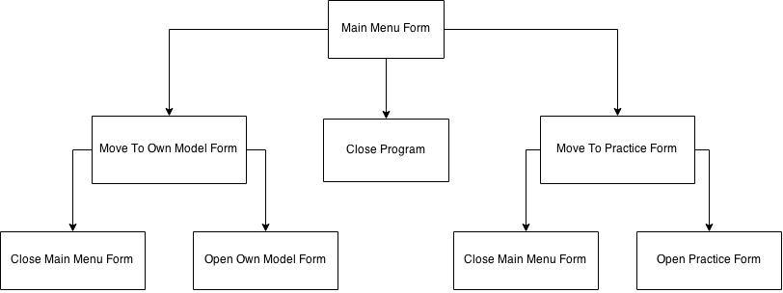

### Own Model Form Structure Chart

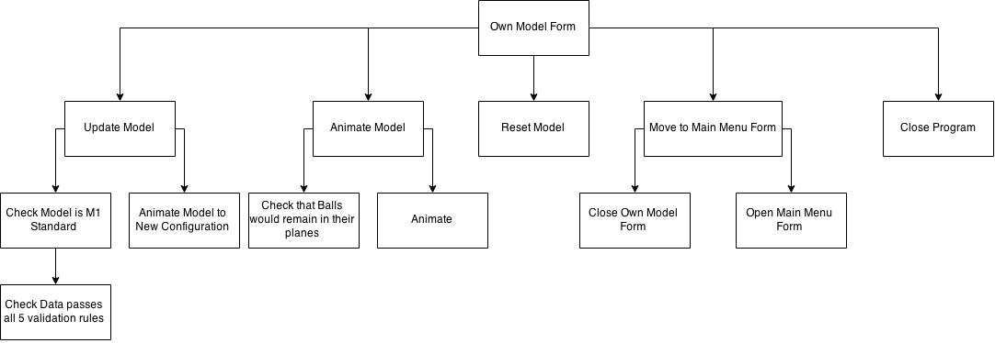

### Practice Form Structure Chart

## Description of modular structure of the system

For my system, I have defined a module as one or more subroutines that contribute to achieving a main piece of system functionality. Therefore, these modules are the Level 1 Functionalities found in Overall System Design. To this end, I would recommend referencing the Overall System Design when trying to understand my design for the system. The description of the modules is tabulated below:

|  |  |  |
| --- | --- | --- |
| **Name of Module** | **Form(s) the module is found in** | **Description** |
| Move to … Form | Main Menu Form, Own Model Form, Practice Form | This module allows the user to traverse the system. Closing the current form and opening the new chosen one. In all forms it will be triggered by a button press. |
| Close Program | Main Menu Form, Own Model Form, Practice Form | This module closes the program. In all forms it will be triggered by a button press. |
| Animate Model | Own Model Form, Practice Form | In general, this module will perform some validation, before animating the given model based on its current configuration. In the Own Model Form, the validation is checking that the Balls would remain in their planes. In the Practice Form, the validation is checking that the User has got all the questions correct. The animation will generally use Force analysis and constant acceleration formulae to calculate movement time over small delta distances, before using the Delphi-Firemonkey animation function to repeatedly animate these distances in those times. Refer to Identification of processes and suitable algorithms for data transformation to find the Animation algorithm. In both forms this module will be triggered by a button press. |
| Update Model | Own Model Form | This module checks that the user defined model is M1 standard before updating the model to its new configuration. Refer to Identification of processes and suitable algorithms for data transformation to find the Update Model algorithm. For more information on the validation checks that this module applies when checking if the model is M1 standard, see Definition of Data Requirements. This module will be triggered by a button press. |
| Reset Model | Own Model Form | This module resets the model to its default configuration. It will be triggered by a button press. |
| Create Random Problem | Practice Form | This module generates an M1 Standard model, displaying the model and all but two of the associated variable values. Moreover, the module displays three questions, one for the two variable values to be found and one questioning the user on direction of motion. Refer to Identification of processes and suitable algorithms for data transformation to find the Create Random M1 Standard Variable Values algorithm. The module will be triggered by a button press. |

## Definition of Data Requirements (validation and processing)

The program will have to validate inputs in the Own Model Form. The validation on each variable will be as follows:

|  |  |
| --- | --- |
| Name (Variable Name) | Individual Validation |
| Mass of Ball 1 (Ball1Mass) | Must be positive and less than or equal to 3 digits in length. |
| Mass of Ball 2 (Ball2Mass) | Must be positive and less than or equal to 3 digits in length. |
| Coefficient of Friction between Ball 1 and the Plank (CoefficientofFriction) | Must be positive and less than or equal to 4 digits in length. |
| Angle of Plank (PlankAngle) | Must be between 0 and 90 and an integer. |
| Length of Plank (PlankLength) | Must be positive and less than or equal to 3 digits in length. |
| Length of String connecting Ball 1 and Ball 2 (StringLength) | Must be positive and less than or equal to 3 digits in length. |
| How far Ball 1 starts up the Plank (DistanceBall1StartsUpPlank) | Must be positive and less than or equal to 3 digits in length. |

Moreover, in both parts of the program the 5 validation rules I defined in my Analysis (see Analysis Data Dictionary for an in depth explanation) must also be kept true for a problem to be M1 standard. These are (Using Variable Names):

*Validation Rule 1:*

**DistanceBall1StartsUpPlank < PlankLength**

*Validation Rule 2:*

**DistanceBall1StartsUpPlank + StringLength > PlankLength**

*Validation Rule 3:*

**(PlankLength * Sin(PlankAngle)) – StringLength + PlankLength – DistanceBall1StartsUpPlank > 0**

*Validation Rule 4(Only applicable if Ball 1 moving up the slope):*

**Distance Ball 1 starts up Plank + InitialMovementLength + ExtraDisplacementLength < PlankLength**

This can also be written as follows if you follow through the calculations:

**(PlankLength * Sin(PlankAngle)) – StringLength + ExtraDisplacementLength < 0**

*Validation Rule 5(Only applicable if Ball 1 moving down the slope):*

**(PlankLength * Sin(PlankAngle)) – StringLength + PlankLength – DistanceBall1StartsUpPlank+ InitialMovementLength + ExtraDisplacementLength < (PlankLength * Sin(PlankAngle))**

This can also be written as follows if you follow through the calculations:

**PlankLength – StringLength + ExtraDisplacementLength < 0**

In the Practice Form model. The user’s answers will have to be validated as to whether the answer is right or not.

An embedded text file and an embedded image file will be used as storage for the executable. These will store a list of questions and the image for the Balls. The embedded text file will store this information:

*What is the Tension in the string? (4SF)*

*What is the Initial Acceleration of the system? (7SF)*

*What is the Angle of Incline? (2SF)*

*What is the Mass of Ball 1? (3SF)*

*What is the Mass of Ball 2? (3SF)*

*What is the Coefficient of Friction? (3SF)*

*What is the Initial Displacement of the System? (3SF)*

*What is the Displacement that occurs after one of the balls hits the ground? (3SF)*

*Does Ball 1 move 'up' the slope or 'down' the slope?*

I will then be able to refer to this text file by line number to retrieve the question I need.

To this end, data will be processed from the user, the random number generator, or the embedded text file and image files.

## Identification of processes and suitable algorithms for data transformation

In this section I will design the non-standard or complicated algorithms that will be used in the system. Due to the nature of the problem, the algorithms tend to be very mathematically complex. Therefore to aid my own understanding for when I refer back to the design later, I have split each algorithm into two parts. The first part will be a high level view of the whole algorithm, which will help me to implement the basic structure of the algorithm when I implement the program. The second part will be a lower level view of one or more particular parts of the algorithm that will help me to regain understanding of the intricacies of the mathematics or algorithm if I forget in the future.

Note that in many of the Low Level View algorithms the following abbreviations are used to make them simpler to understand:

|  |  |
| --- | --- |
| Variable | Abbreviation |
| Ball1Mass | M1 |
| Ball2Mass | M2 |
| CoefficientofFriction | u |
| PlankAngle | **θ** |
| PlankLength | PL |
| StringLength | SL |
| DistanceBall1StartsUpPlank | DB1S |

### Animating a model (Part of Animate Model Module)

This is the core functionality of the program (it is used in Own Model Form and Practice Form) and is by far the most complicated algorithm. It is made very complicated because I can’t just use Delphi-Firemonkey’s built in animation functionality to move a Ball from A to B, as this gives no sense of acceleration. I have to use the built in animation many times over extremely small delta distances, working out the time that the Ball would take to travel that distance under the acceleration. Note that in both views of the algorithm, the ‘SmoothnessConstant’ or ‘SC’ will be a programmer defined constant that will define how smooth the animations are. The greater the integer, the smoother the animation.

#### High Level View

Begin

Calculate If Upslope,DownSlope or Stationary

If Upslope

Calculate InitialMovementLength

Calculate ExtraDisplacementLength

DeltaInitialMovementLength InitialMovementLength/SmoothnessConstant

DeltaExtraDisplacementLength ExtraDisplacementLength/SmoothnessConstant

If Not M1 problem using Validation Rule 4 Then output error

Else

For 1 to SmoothnessConstant do

Calculate Time for Balls to move another DeltaIntialMovementLength

Calculate New X and Y coordinates for each ball

Calculate New lengths of String

Animate Ball 1 upslope Ball 2 downwards using calculated time

EndFor

For 1 to SmoothnessConstant do

Calculate Time for Ball 1 to move DeltaExtraDisplacementLength up slope

Calculate New X and Y coordinates for Ball 1

Calculate New lengths of String

Animate Ball 1 upslope using calculated time

EndFor

For 1 to SmoothnessConstant do

Calculate Time for Ball 1 to move DeltaExtraDisplacementLength down slope

Calculate New X and Y coordinates for Ball 1

Calculate New lengths of String

Animate Ball 1 downslope using calculated time

EndFor

EndIf

If DownSlope

Calculate InitialMovementLength

Calculate ExtraDisplacementLength

DeltaInitialMovementLength InitialMovementLength/SmoothnessConstant

DeltaExtraDisplacementLength ExtraDisplacementLength/SmoothnessConstant

If Not M1 problem using Validation Rule 5 Then output error

Else

For 1 to SmoothnessConstant do

Calculate Time for Balls to move another DeltaIntialMovementLength

Calculate New X and Y coordinates for each ball

Calculate New lengths of String

Animate Ball 1 downslope Ball 2 upwards using calculated time

EndFor

For 1 to SmoothnessConstant do

Calculate Time for Ball 2 to move DeltaExtraDisplacementLength upwards

Calculate New Y coordinates for Ball 2

Calculate New lengths of String

Animate Ball 2 upwards using calculated time

EndFor

For 1 to SmoothnessConstant do

Calculate Time for Ball 2 to move DeltaExtraDisplacementLength downwards

Calculate New Y coordinates for Ball 2

Calculate New lengths of String

Animate Ball 2 downwards using calculated time

EndFor

EndIf

If Stationery

Output Why Stationery

EndIf

End

#### Low Level View

##### Calculating if Upslope, Downslope or Stationery

##### 

##### 

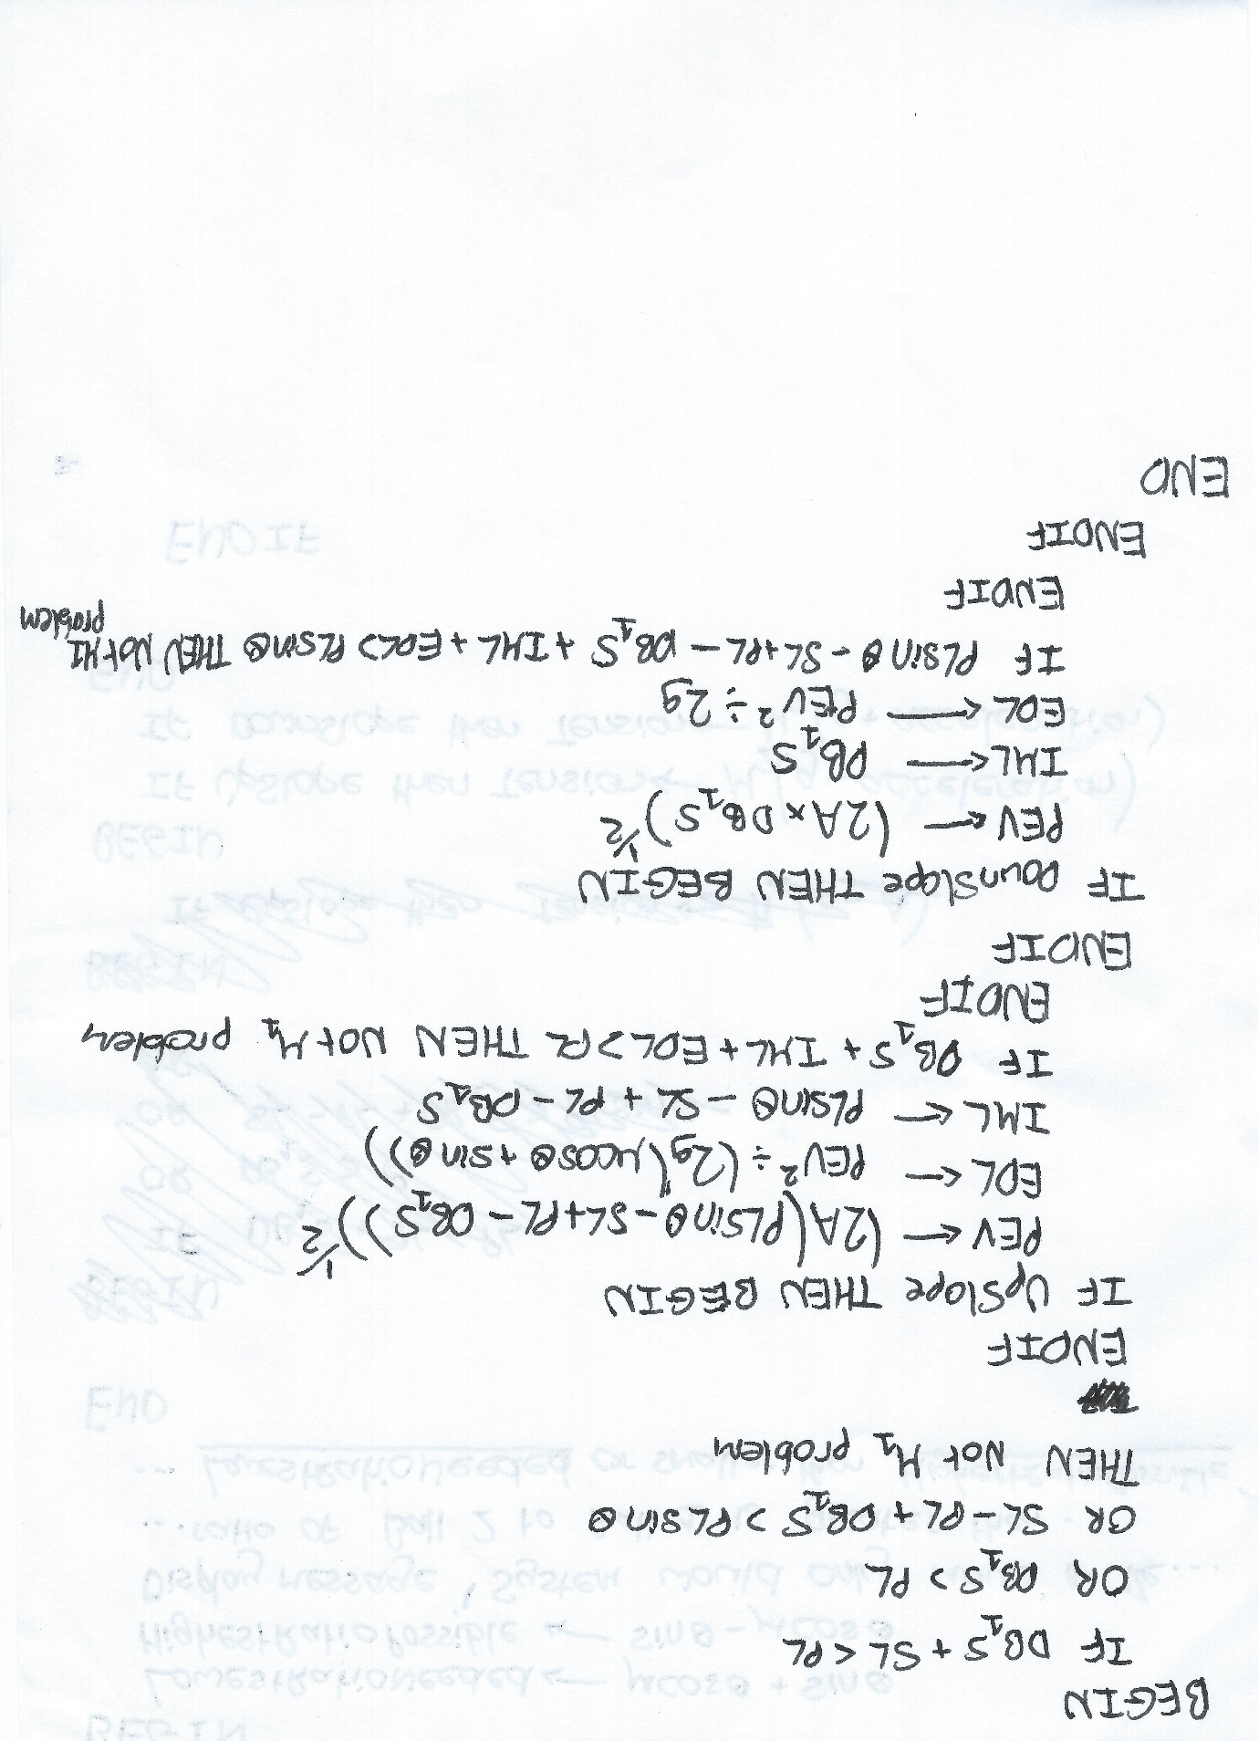

##### Animation

I have only designed a Low Level view for the UpSlope animation because I can see from my High Level design that the DownSlope animation will be extremely similar:

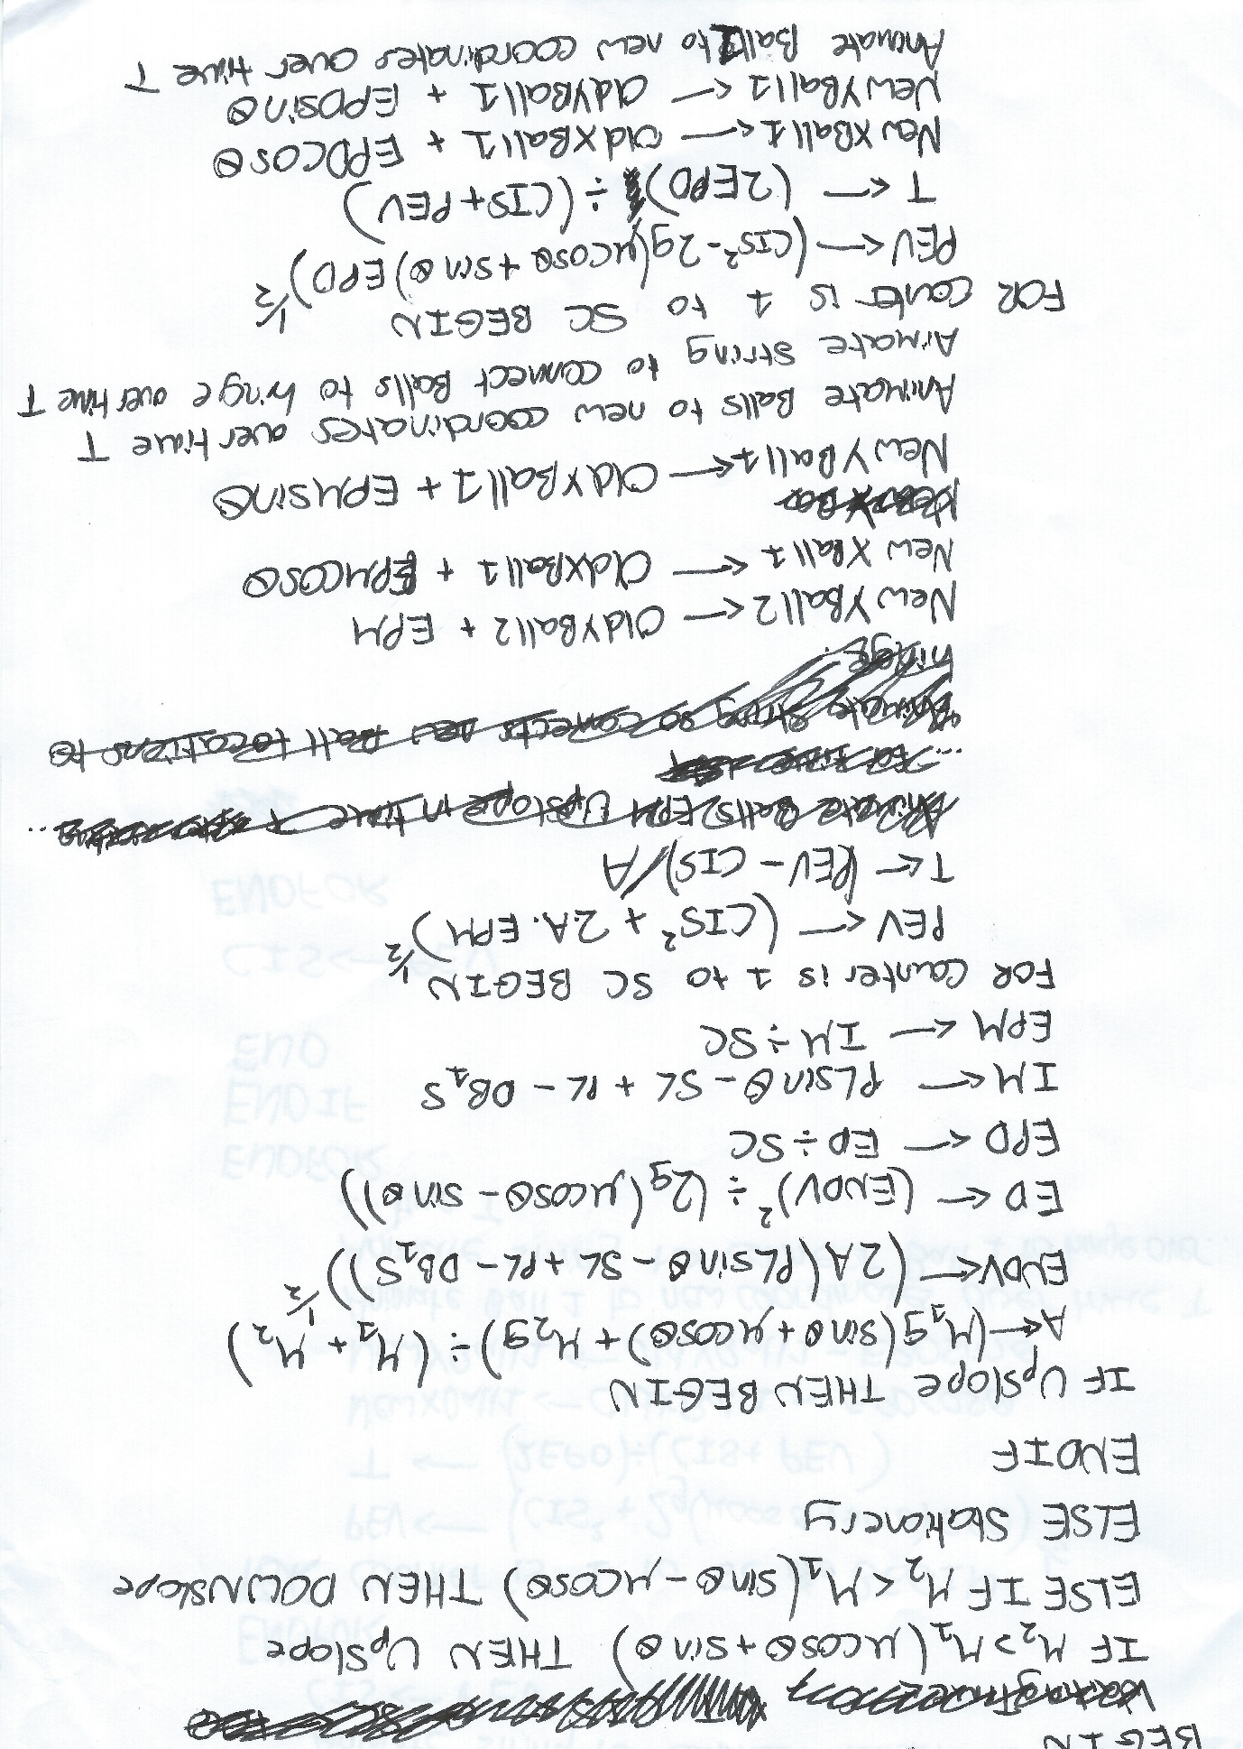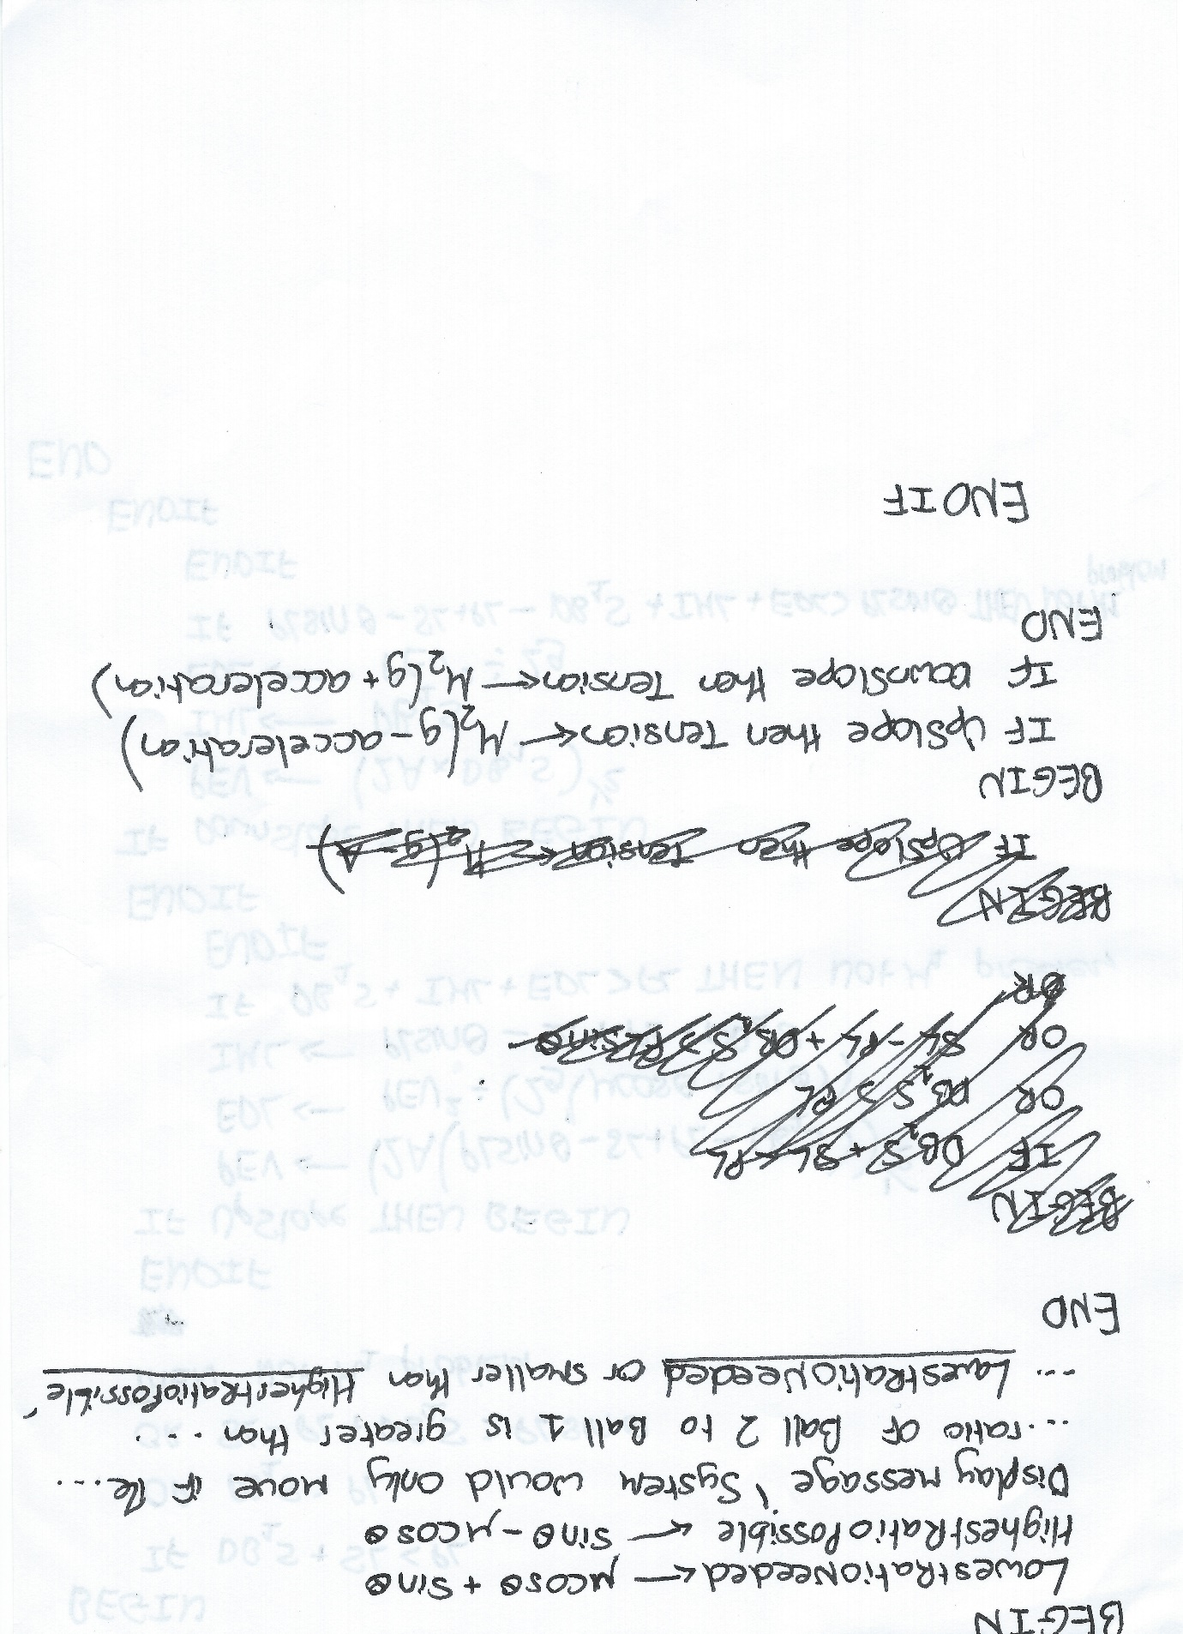

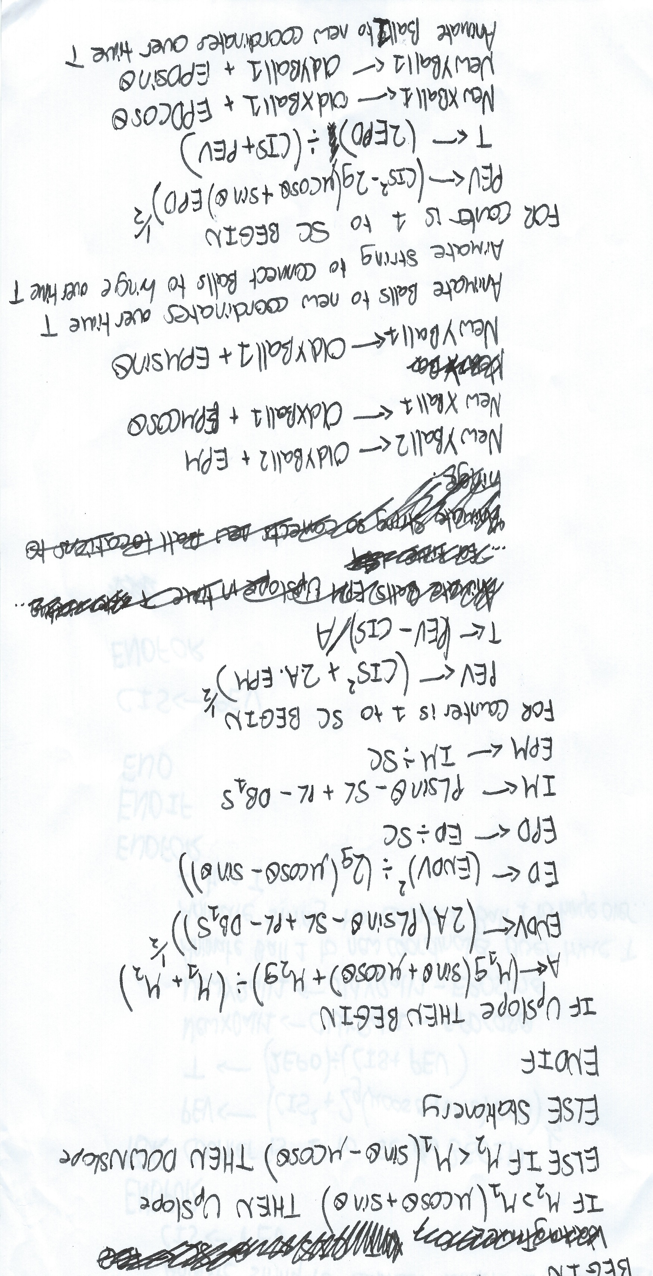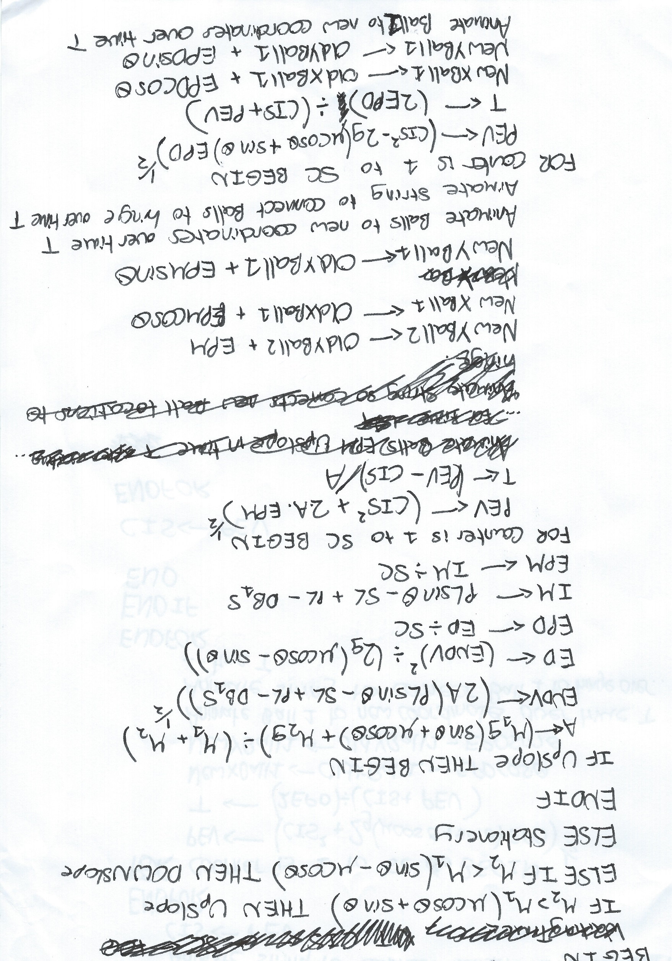

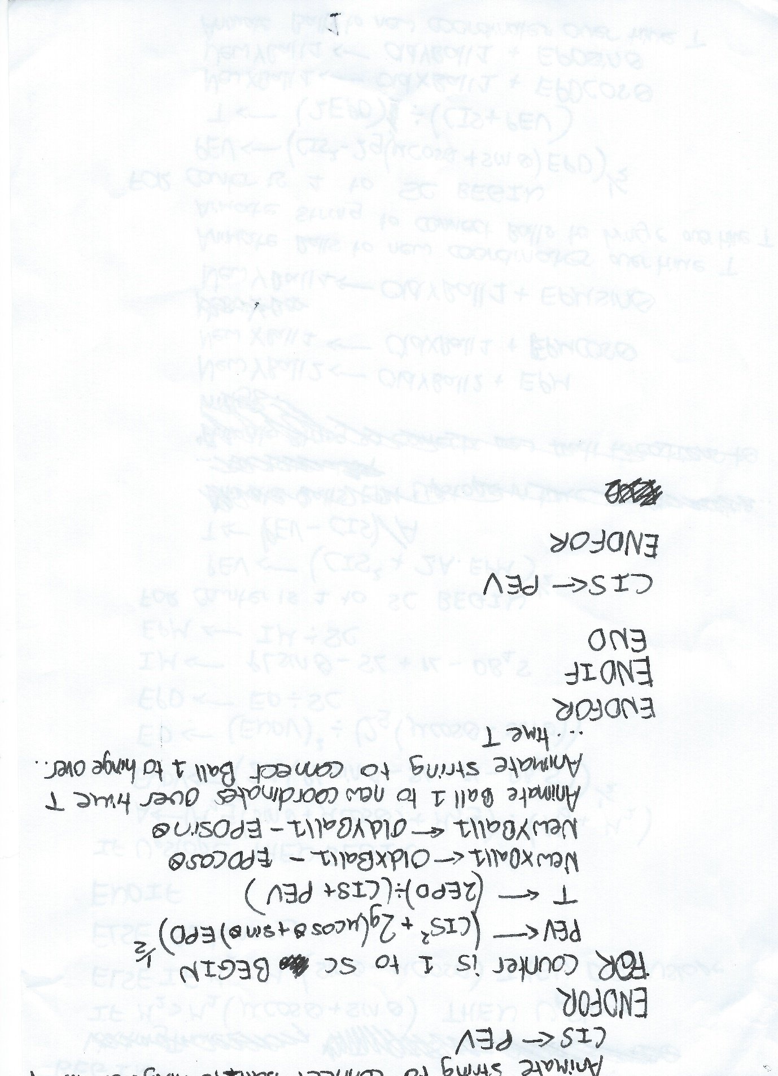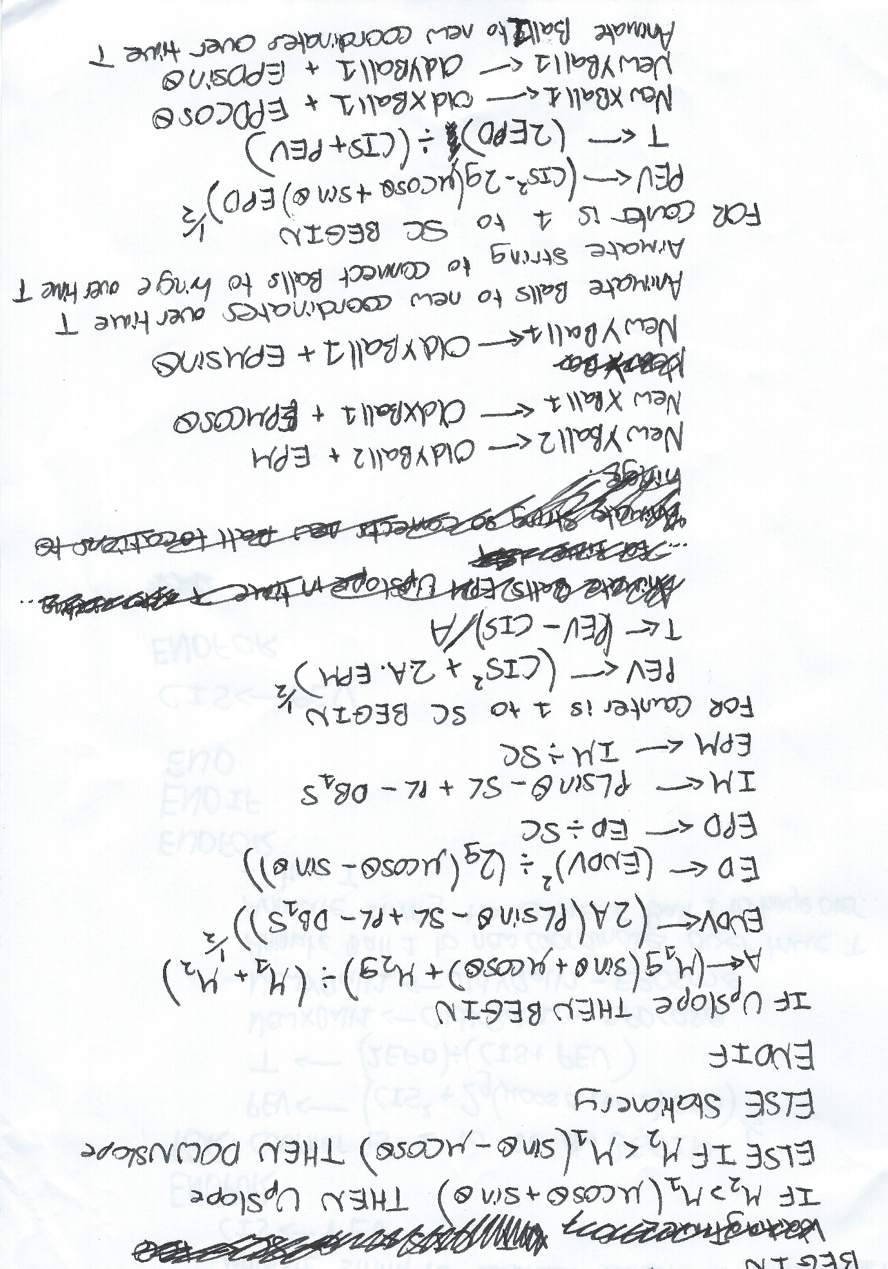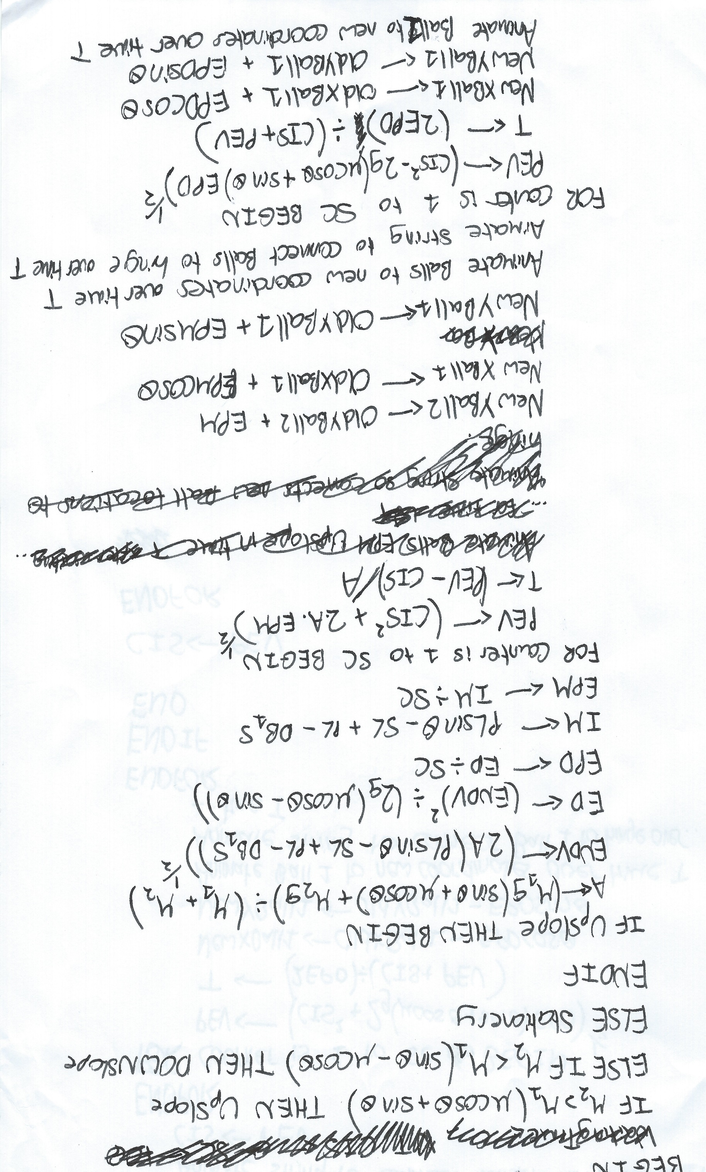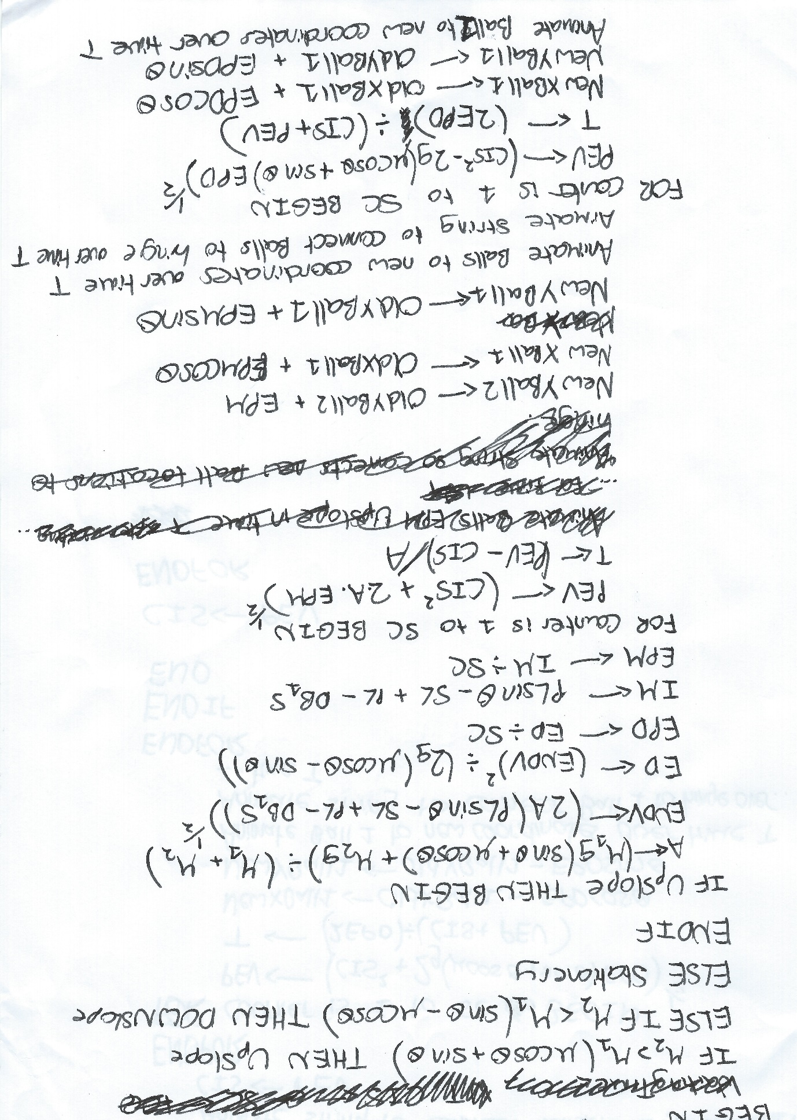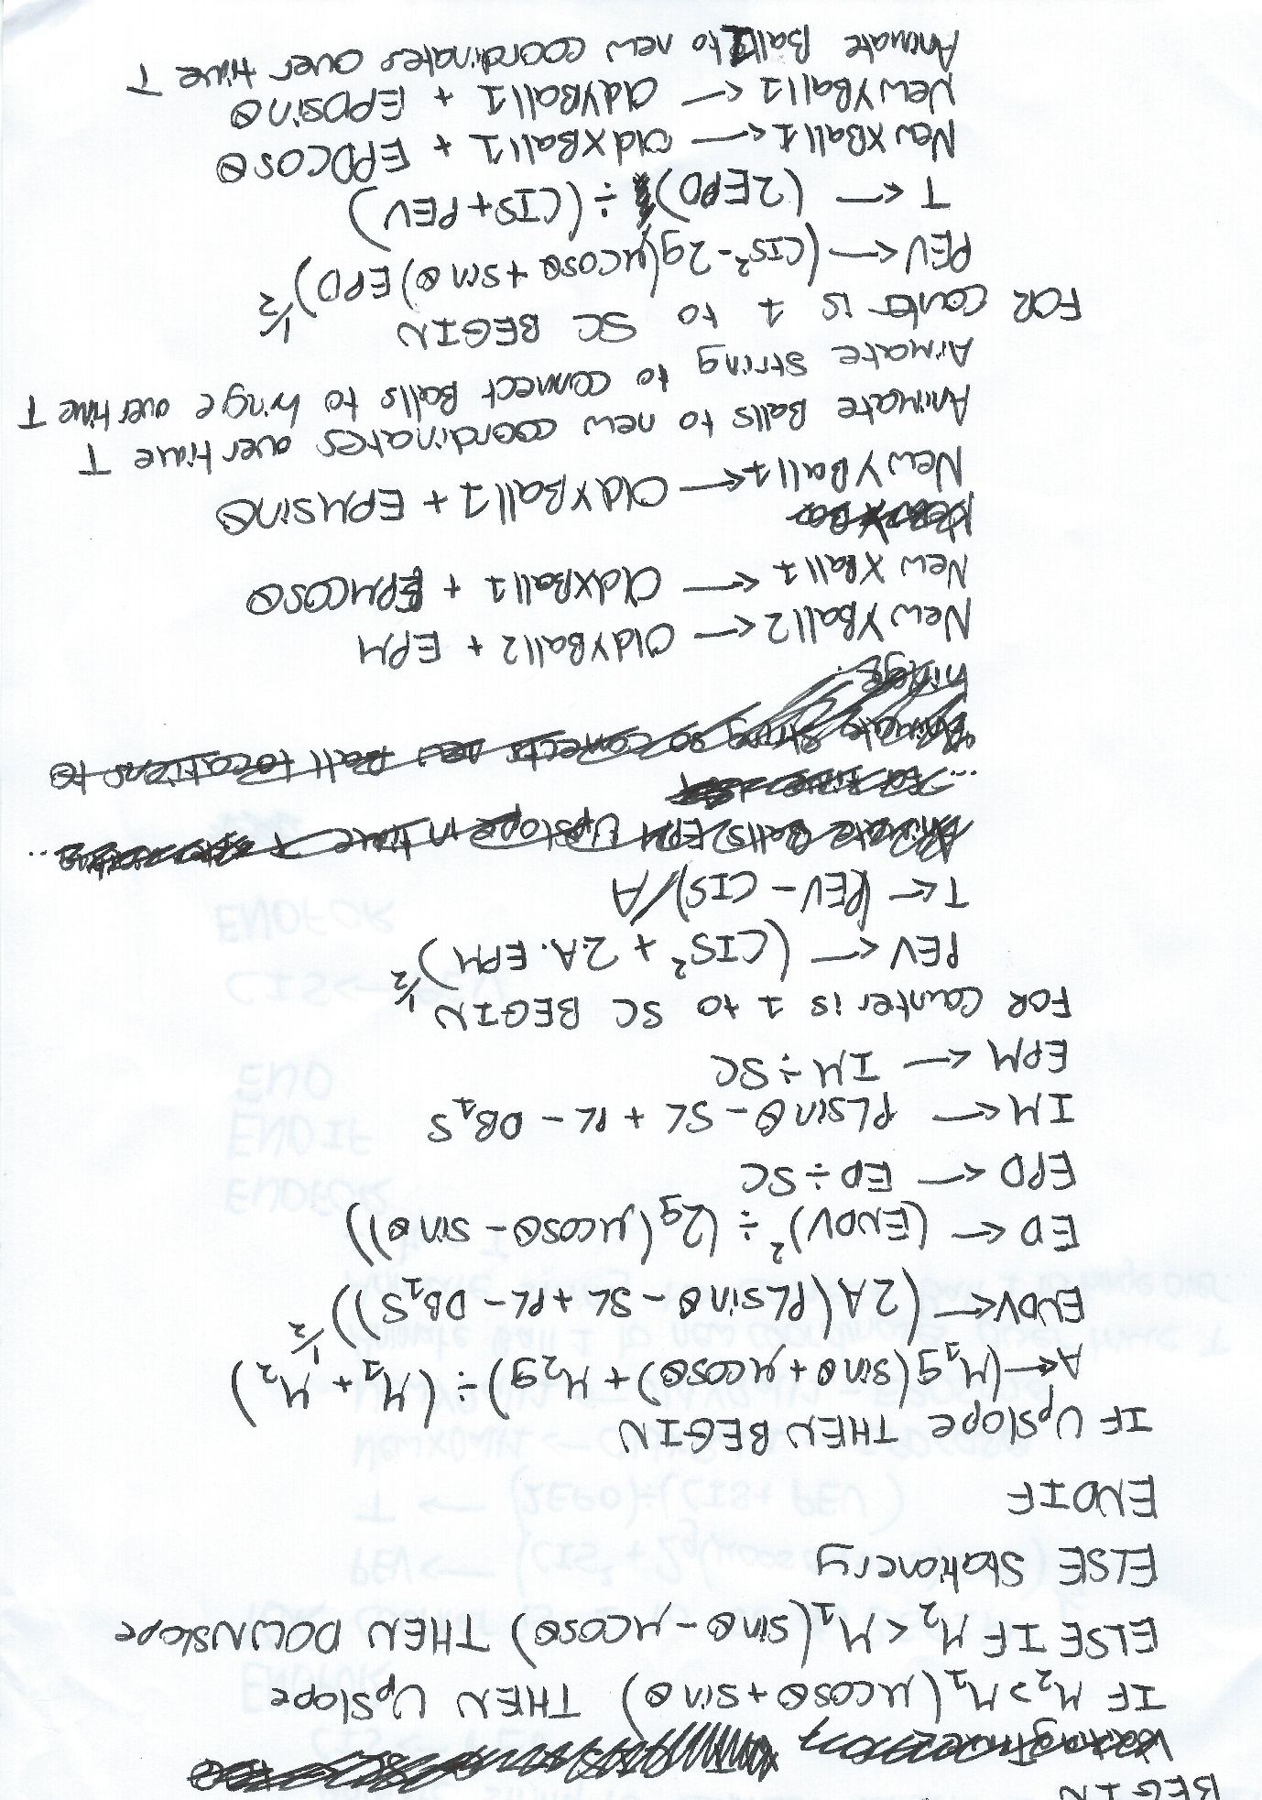

##### 

##### 

##### 

##### Outputting why Stationary

##### 

##### 

### Update Model Module

This algorithm is used in Own Model Form and updates the displayed model to a user defined model. For more information on the validation rules used here see the Definition of Data Requirements.

#### High Level View

Begin

If FormHeight<FormWidth then HeightOfPlankPixels FormHeight

Else HeightOfPlankPixels FormWidth

Validate that M1 problem using validation rules 1-3, If not M1 problem then Output error

Else

TopOfSlopeX HeightOfPlankPixels*Sin(90-PlankAngle)

TopOfSlopeY HeightOfPlankPixels*Cos(90-PlankAngle)

Animate Plank Angle

Animate Plank String Angle

Animate String to TopOfSlopeX,TopOfSlopeY

Animate Balls to correct positions

Animate String Lengths

EndIf

End

#### Low Level View

None needed. This algorithm is much simpler than the other two I have designed.

### Create Random Problem Module

This algorithm is used in Practice Form. It creates the random model along with the questions for that model. It takes into account that if a question on Ball 1’s mass is asked then a question on the coefficient of friction or plank angle cannot be asked as it would be an unsolvable problem.

#### High Level View

Begin

While not M1 Problem do Create Random Values of correct digit length

Calculate Tension

Load Questions From Embedded File

While

RandomInteger1=RandomInteger2

Or Random1Integer1=4 and RandomInteger2=6

Or Random1Integer1=6 and RandomInteger2=4

Or Random1Integer1=3 and RandomInteger2=6

Or Random1Integer1=6 and RandomInteger2=3

Do

RandomInteger1 Random number between 1 and 6 inclusive

RandomInteger2 Random number between 1 and 8 inclusive

EndWhile

Case RandomInteger1:

1: TensionQuestion True

2: AccelerationQusetion True

3: AngleQuestion True

4: Ball1MassQuestion True

5: Ball2MassQuestion True

6: CoefficientQuestion True

EndCase

Case RandomInteger2:

1: TensionQuestion True

2: AccelerationQusetion True

3: AngleQuestion True

4: Ball1MassQuestion True

5: Ball2MassQuestion True

6: CoefficientQuestion True

EndCase

Question1 QuestionsFile[9]

Question2 QuestionsFile[RandomInteger1]

Question3 QuestionsFile[RandomInteger2]

If TensionQuestion = true then don’t display Tension

Else display Tension

If AccelerationQuestion = true then don’t display Acceleration

Else display Acceleration

If AngleQuestion = true then don’t display Angle

Else display PlankAngle

If Ball1MassQuestion = true then don’t display Ball1Mass

Else display Ball1Mass

If Ball2MassQuestion = true then don’t display Ball2Mass

Else display Ball2Mass

If CoefficientQuestion = true then don’t display Coefficient

Else display CoefficientofFriction

Update the Model to the new configuration

End

#### Low Level View

##### Calculating the Tension

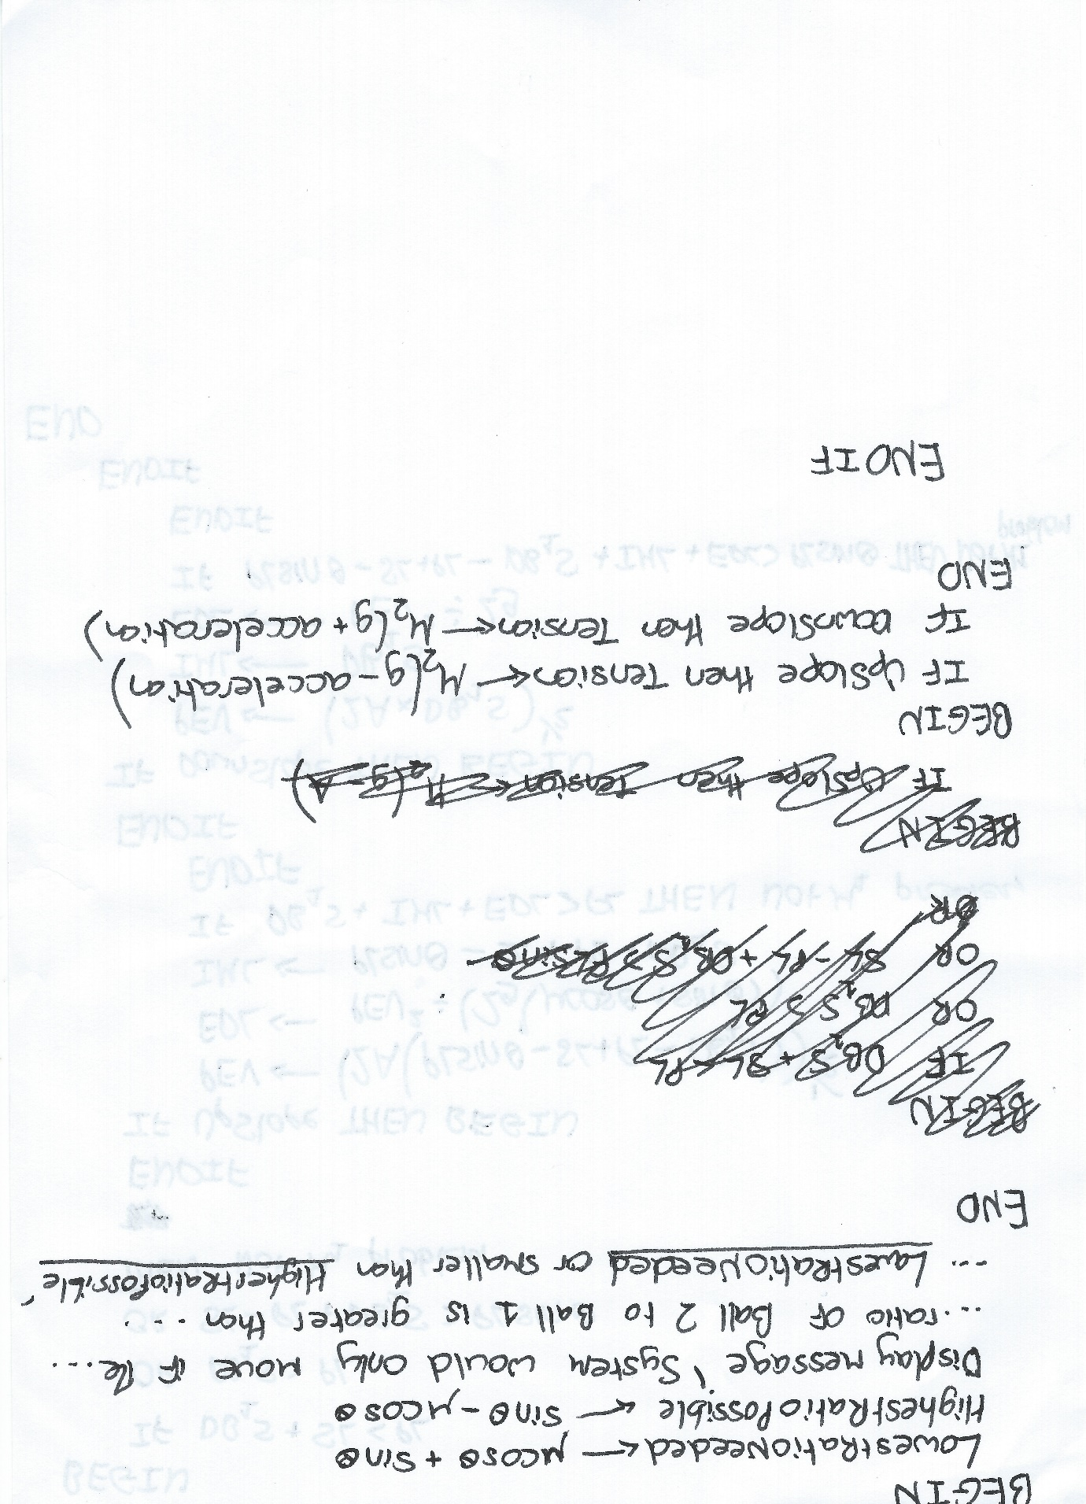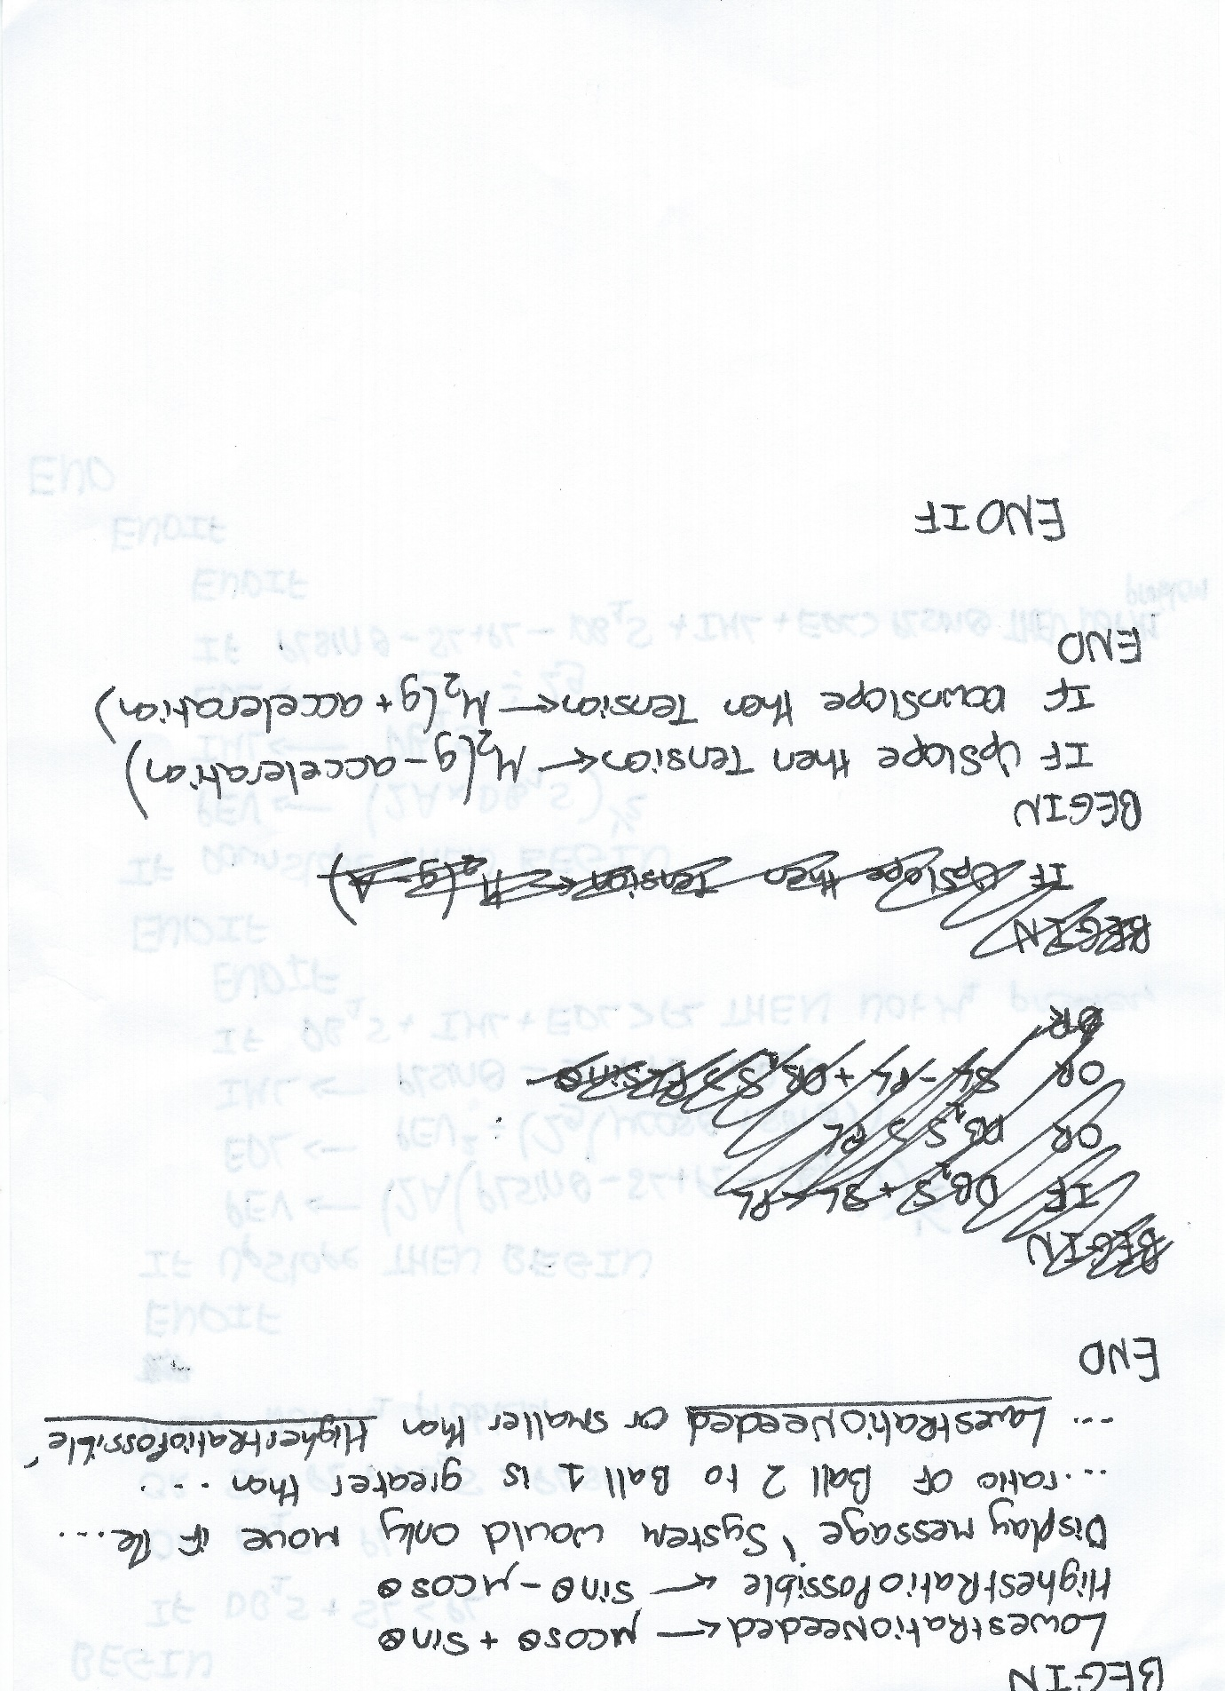



##### Checking if Random Values Satisfy an M1 problem

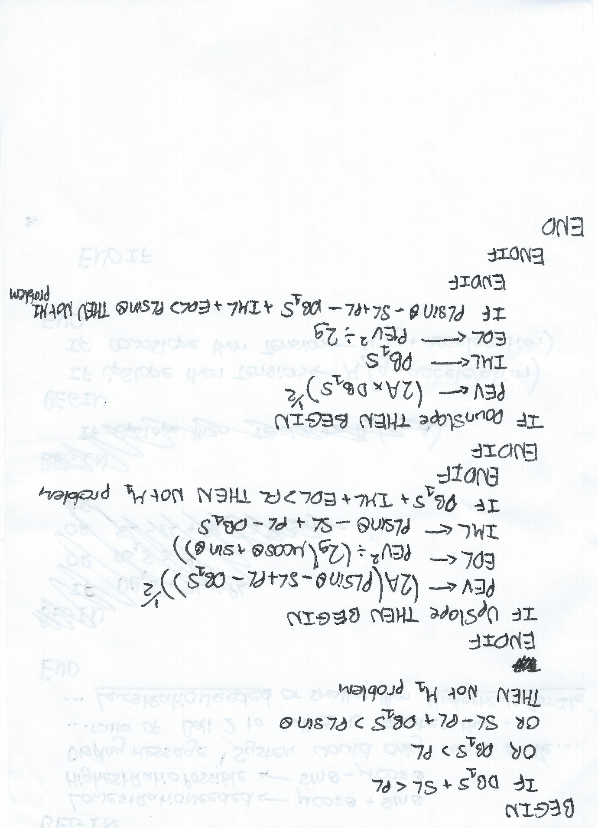

##### 

## Class/Object Diagrams/Definitions and details of object behaviours and methods

My self-defined TBall class will inherit from the TImage class:

TImage

TBall

This will give the TBall class the ability to display an image on screen from a file, while also allowing me to take advantage of the ‘animate’ method.

I have overridden the Create and Destroy methods from TImage so a member of the TBall class can be shown and hidden using a resource file.

## User Interface design (HCI) rationale:

I would like the design of the program to reflect what it will be used for. This being an educational tool to be used in school. To this end, the colour scheme will be grey and black, to maintain a business-like feel and not confuse the user. The font used will be Segoe UI. I have chosen this font because I feel it is very clear and easy to read. I will use size 18 font for button captions, size 28 font for information and size 36 font for titles.

As described earlier, I plan to have 3 forms in the program:

1. The ‘Main Menu’ Form. This will allow the user to traverse the program.
2. The ‘Own Model’ Form. This will allow the user to create their own M1 Model and watch it animate.
3. The ‘Practice’ Form. This will randomly generate an M1 model for the user, and question them on it.

All forms will scale with screen size and be full screen to fit the user’s requirement. In the ‘Own Model’ and ‘Practice’ form, I like the layout to be similar for ease of use, even if the controls are different. Generally, information and user input will take place on the right side of the screen, while on the left side of the screen the model will be displayed.

### Sample of planned data capture and entry designs:

#### Main Menu Form

Buttons to either go to one of the other forms or close the program.

#### 

Buttons to either return to the main menu or close the program.

#### Own Model Form

Spin-boxes to all user to only select integers

Text-boxes to allow user to make selections

Buttons to either update the model, animate the model, or reset the model to default values. Note that the update button can be triggered by pressing the enter key.

#### 

Buttons to either return to the main menu or close the program.

#### Practice Form

Text-Boxes to allow user to answer questions.

Buttons to check user answers and if correct animate, or generate a new problem.

### Sample of planned valid output designs:

#### Own Model Form

If the user presses the reset button these selectors will be reset to default values. If an invalid entry is made that entry will be reset to its default value.

Model displayed here, it will update to the user defined values, animate based on the user defined values, or reset to default values based on what buttons/keys the user presses.

#### Practice Form

These values are displayed based on the generated model and what questions are being asked.

Model displayed here, it will animate if the user checks their answers and they are correct. It will also change to a new problem if the respective button is pressed.

#### Displayed Messages

At some point during the problem, a message has to be displayed on screen. For example, this may be a message informing the user why an input is invalid. I will use the built in ‘Showmessage’ function in Delphi, which produces a message which looks like:

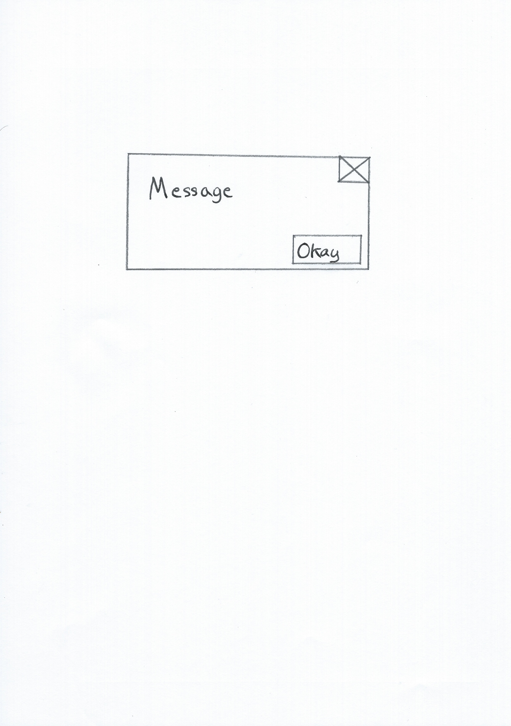

## Description of measures planned for security and integrity of data

My school, Merchant Taylors’, has a policy that restricts any pupil from running any executable file. Therefore to make the program usable by both teachers and pupils, I will have to get permission from the IT department to distribute the program’s executable across the school’s network. The permission to run the executable will then have to be distributed to all pupils.

As all data files used are to be embedded within the program’s executable by using a resource file, there is no chance of data loss without the program itself being lost. The program itself will be distributed to all computers (including those connected to smart boards) via the school’s network. Therefore the only chance of losing the program is if the school’s network to fail. Luckily, the school’s network is very safe as it has high redundancy due to the use of a RAID 5 array and is backed up often. A full backup is performed onto a backup server each day based on the daily incremental changes that have occurred on the network. Additionally, magnetic tape backups are kept off site in the event of both the school’s network and the backup server failing.

## Description of measures planned for system security

The program will be stored in compiled form on the school’s network. This means that everyone will be able to access the executable without being able to alter or see the system code. The program does not store any sensitive data, so no additional security needs to be planned.

## Overall test strategy in relation to the problem being solved and tested

In order to properly test the program, I will test all functionality of the program using normal data. Boundary and erroneous data will be used where applicable. I will then compare my results to my original objectives for the system so that I can evaluate my tests.